LAB 3: SNIFFING AND ANALYSING NETWORK PACKETS

Exercise 3A: PACKETS CAPTURING

List the sequence of all relevant network packets sent and received by your laboratory PC from the time your Rfc865UdpClient initiated a request to the DNS server to resolve the QoD server name till it received the quote of the day. Fill in the MAC and IP address of the packets where appropriate/available.

Packet | Source  MAC | Source IP | Dest. MAC | Dest. IP | Purpose of Packet
1. | 00:4e:01:bd:c1:60 | 10.96.181.220 | 00:00:0c:9f:f0:f0 | 155.69.3.8 | DNS request
2. | cc:b6:c8:85:4e:cb | 155.69.3.8 | 00:4e:01:bd:c1:60 | 10.96.181.220 | DNS response
3. | 00:4e:01:bd:c1:60 |  | a4:27:a5:5b:f4:20 |  | ARP request
4. | a4:27:a5:5b:f4:20 |  | 00:4e:01:bd:c1:60 |  | ARP reply
5. | a4:27:a5:5b:f4:20 | 10.96.181.220 | 00:4e:01:bd:c1:60 | 10.96.189.98 | UDP request
6. | 00:4e:01:bd:c1:60 | 10.96.189.98 | a4:27:a5:5b:f4:20 | 10.96.181.220 | UDP reply

Determine the IP address of DNS server: 155.69.3.8
Determine the IP address of the QoD server: 10.96.189.98
What is the MAC address of the router? a4-27-a5-5b-f4-20

Exercise 3B: Data Encapsulation

Complete Captured Data

(please fill in ONLY 8 bytes in a row, in hexadecimal)

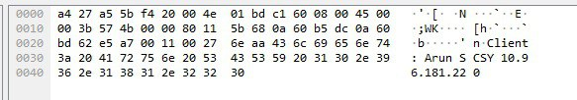

Exercise 3C: DATA LINK PDU - Ethernet Frame

What type of upper layer data is the captured ethernet frame carrying?
How do you know?
- IPv4 protocol. The ethernet protocol type frame is 0x08 00 which means that the frame is carrying IPv4 protocol.

Determine the following from the captured data in Exercise 3B:

Destination Address | a4 27 a5 5b f4 20
Source Address | 00 4e 01 bd c1 60
Protocol | 08 00 (IPv4)
Frame Data

(8 bytes in a row, in hexadecimal)

Exercise 3D: NETWORK PDU - IP Datagram

What type of upper layer data is the captured IP packet carrying? How do you know?
- UDP protocol. The field protol is 0x11, so we knoe that it carries UDP protocol

Does the captured IP header have the field: Options + Padding? How do you know?
- No. There are no bits after destination address in the IP datagram and before the data packet. So, no bits were used for options + padding.

Determine the following from the Frame Data field in Exercise 3C:

Version | 4
Total Length | 59
Identification | 0x574b (22347)
Flags  (interpret the meanings) | 000. …. = Flags: 0x0  0… …. = Reserved bit: Not set  .0.. …. = Don’t fragment: Not set  ..0. …. = More fragments: Not set  …0 0000 0000 0000 = Fragment Offset: 0
Fragment Offset | 0
Protocol | UDP (17)
Source Address | 10.96.181.220
Destination Address | 10.96.189.98
Packet Data

(8 bytes in a row, in hexadecimal)

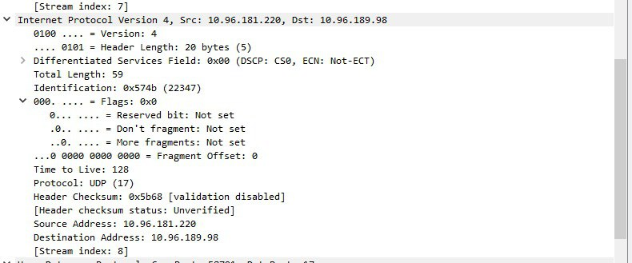

Exercise 3E: TRANSPORT PDU - UDP DATAGRAM

Determine the following from the Packet Data field in Exercise 3D:

Source Port | 58791
Destination Port | 17
Length | 39
Data

(8 bytes in a row, in hexadecimal)

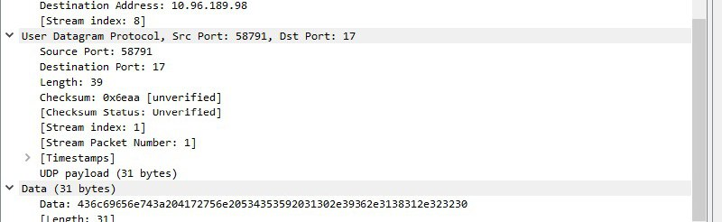

Exercise 3F: Application PDU

Interpret the application layer data from the Data field in Exercise 3E:

Message | Arun SCSY 10.96.181.220

Is this the message that you have sent? Yes

